

V 1.2
June 2026
XStep Design Specification
SMPL: Goods Receipt

Table of Contents
1 Purpose 3
2 Overview 3
3 Reasons for Developing 4
4 Authorization 4
5 Assumptions/Dependencies 4
6 Security Objects 4
7 Validation Checks 4
8 Configuration Specification 4
9 Xstep Layout Design 5
10 Function Module(s) 5
11 Pseudocode 8
12 Test Scenarios 11
13 Revision History 12

Purpose
This document outlines the design, as well as the configuration specifications for the XStep “SMPL: Goods Receipt”.

Overview
The purpose of the SMPL: Goods Receipt XStep is to summarize the critical finished product information linked to the process order and perform the necessary inventory and financial record updates in SAP.
The XStep contains the following main input parameters:
- IV_HEADER - The default header text can be edited in SIMPL MBR to display the specific header text for the XStep.
- IV_INSTR - The default instruction text can be edited in SIMPL MBR to display the specific header text for the XStep.
- IV_SIGN – This can be changed in SiMPL MBR to author standalone signatures as part of the xstep.
The process order is generated. After completion of the entire process to create the finished product, the operator utilizes the SMPL: Goods Receipt XStep to verify the process order information prior to signoff and process completion.
The following fields are automatically populated prior to execution of the XStep:
- The Material field automatically populates the material number.
- The Material Description field automatically populates the description attached to the material.
- The Batch field automatically populates the batch number of the set of finished goods manufactured.
- The Quantity field automatically populates the quantity of the finished product within the manufactured batch, but allows for change if the quantity needs to be adjusted.
- The UoM field automatically populates the unit of measure associated with the manufactured finished product.

Functional Design
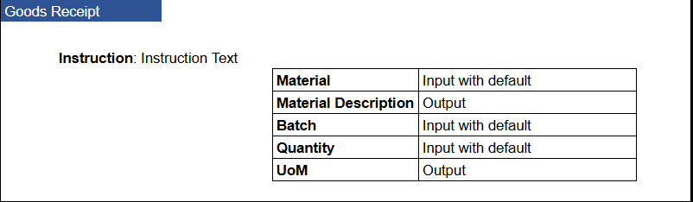

Reasons for Developing
The SMPL: Goods Receipt XStep serves as a record of the manufactured materials after completion of the entire process. The XStep retrieves the critical details linked to the process order, namely the Material, Material Description, Batch, Quantity and UoM and ensures record is kept of the finished product manufactured. After execution of the XStep, the relevant details and quantities are updated within SAP.

Authorization
N/A

Assumptions/Dependencies
N/A

Security Objects
Object Name | Description
Signature validation | Optional

Validation Checks
N/A

Configuration Specification
Goods Receipt Configuration (PI_PROD)
The process message PI_PROD is used to communicate goods receipt data from the XStep execution to the backend system. This message handles material material receipt postings (typically movement type 561) for the components used in production. During execution, the XStep collects and transfers relevant component data such as material number, batch, received quantity, unit of measure, storage location. The message is triggered upon confirmation of the Goods Receipt XStep fields and ensures that the component receipt is correctly reflected in the process order. All generated process messages are captured in transaction CO54, where they can be monitored and processed/sent. Configuration of PI_PROD allows flexible mapping of input parameters and supports integration with both standard and custom logic for inventory updates and traceability.

Xstep Layout Design
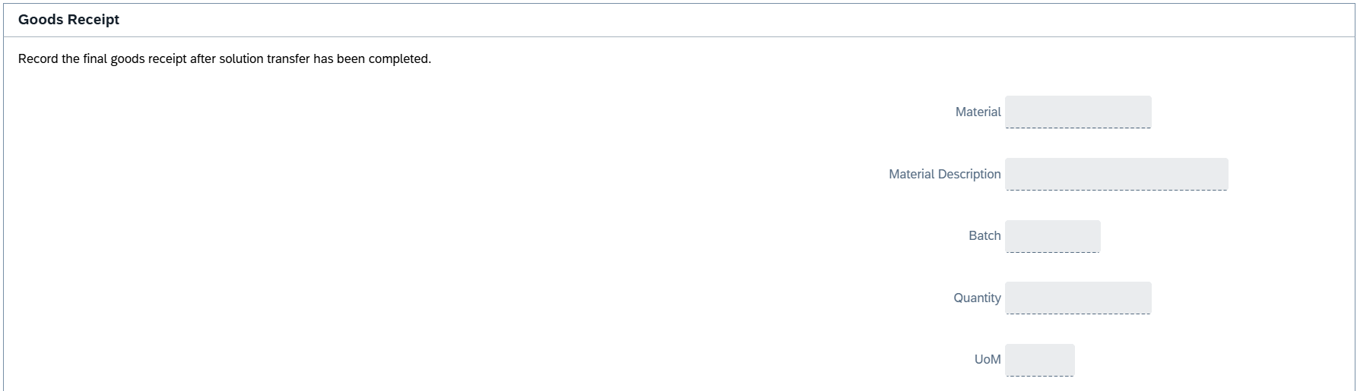

Function Module(s)
Function: /SMPL/PPPI_FM_INITIAL_ACTIVE
Import Parameters:
Parameter Name | Associated Type | Short Text
IV_ACTIVE | CHAR1 | Active Flag
Export Parameters:
Parameter Name | Associated Type | Short Text
EV_ACTIVE | CHAR1 | Active Indicator

Function: /SMPL/MBR_DEP_CHECK_ACTIVE
Import Parameters:
Parameter Name | Associated Type | Short Text
IM_CONTROL_RECIPE | POC_DOCID | Control Recipe Number
IM_PHASE | VORNR | Activity Number
IM_AUFNR | AUFNR | Order Number
IM_STEP_UUID | /SMPL/MBR_SOG_UUID | XStep SOG UUID
IM_PLANT | WERKS_D | Plant
Export Parameters:
Parameter Name | Associated Type | Short Text
EV_ACTIVE | CHAR1 | Active Indicator
Exceptions:
Exception | Short Text
CONTROL_RECIPE_INITIAL | Control recipe is initial

Function: ZSMPL_FM_OUTPUT_BATCH_SIZE
Import Parameters:
Parameter Name | Associated Type | Short Text
IV_DEF_PL_QTY | ERFMG | Default Planned Quantity
IV_PL_QTY | ERFMG | Planned Quantity
IV_ACT_QTY | ERFMG | Actual (Received) Quantity
Export Parameters:
Parameter Name | Associated Type | Short Text
EV_PO_QTY | ERFMG | Process Order Quantity (Batch Size)
EV_RATIO | ERFMG | Reduction Ratio

Function: GET_SYSTEM_TIME_REMOTE
Export Parameters:
Parameter Name | Associated Type | Short Text
K_DATE | DATS | Kernel Date
K_TIME | TIMS | Kernel Time
L_DATE | DATS | Local Date
L_TIME | TIMS | Local Time

Function: ZSMPL_FM_GET_MAT_DETAIL
Import Parameters:
Parameter Name | Associated Type | Short Text
IM_MATNR | MATNR | Material Number
Export Parameters:
Parameter Name | Associated Type | Short Text
EX_MAT_DESC | MAKTX | Material Description
EX_UOM | MEINS | Base Unit of Measure
Exceptions:
Exception | Short Text
MAT_DESC_DNE_FOR_LANGU | Material description not found for language
UOM_NOT_FOUND | Unit of measure not found

Pseudocode
Function: /SMPL/PPPI_FM_INITIAL_ACTIVE
1. Initialization
a. Input parameter IV_ACTIVE is optionally provided by the calling logic.
b. Constants GC_YES, GC_NO and GC_INSIDE_RANGE are defined in the function-group TOP include (GC_INSIDE_RANGE = GC_YES = '1', GC_NO = '2').
2. Active Flag Evaluation
a. Compare IV_ACTIVE against GC_INSIDE_RANGE.
b. If IV_ACTIVE is not equal to GC_INSIDE_RANGE, set EV_ACTIVE = GC_NO ('2'); if it is equal, set EV_ACTIVE = GC_YES ('1').
3. Output Assignment
a. The evaluated result is returned in EV_ACTIVE for use by the calling logic (e.g., XStep activation in the PI Sheet).
Additional Notes
Simple normalization function: no database access, validation or exceptions.
IV_ACTIVE is optional; if not supplied it is initial (not equal to GC_INSIDE_RANGE), so EV_ACTIVE defaults to GC_NO ('2').
Function: /SMPL/MBR_DEP_CHECK_ACTIVE
1. Initialization
a. Imports IM_CONTROL_RECIPE, IM_PHASE (optional), IM_AUFNR (optional), IM_STEP_UUID and IM_PLANT. If IM_CONTROL_RECIPE is initial, raise CONTROL_RECIPE_INITIAL.
b. PERFORM LOAD_INTERNAL_DATA to (re)load the order's dependency rows from /SMPL/MBR_OR_DEP into the function-group cache, keyed by order / control recipe.
2. Signature Data Retrieval
a. Re-select the order's signatures (AUFNR, SOG_UUID, TYPE, SIGN_ID, created/sign dates and times, DEST_NAME) from /SMPL/MBR_OR_SIG WHERE AUFNR = IM_AUFNR.
3. Dependency Evaluation
a. Loop the cached dependencies where TARGET_UUID = IM_STEP_UUID and DEP_RULE is a before-start rule (PERFORM_START or VERIFY_START).
b. For each, check whether the prerequisite step's perform / verify signature is still unsigned (SIGN_ID initial).
4. Output Assignment
a. If an unsigned prerequisite is found, EV_ACTIVE = step-inactive ('1'); otherwise EV_ACTIVE = step-active ('2').
Additional Notes
Read-only FM: reads /SMPL/MBR_OR_DEP (cached) and /SMPL/MBR_OR_SIG (always refreshed), plus AFKO for order type.
Raises CONTROL_RECIPE_INITIAL when the control recipe is missing; empty dependency / signature data is tolerated.
Function: ZSMPL_FM_OUTPUT_BATCH_SIZE
1. Calculate New Batch Size
a. EV_PO_QTY = IV_PL_QTY - IV_ACT_QTY (planned quantity minus the quantity already received).
b. If the result is negative, set EV_PO_QTY = 0 and warn the operator that the batch size cannot be negative (frontend websocket warning when GV_FUNCTION = 'SMPL_EBR', otherwise a GUI message).
2. Pass Reduction Ratio
a. If IV_ACT_QTY is not initial: when the planned quantity equals the default planned quantity, EV_RATIO = EV_PO_QTY / IV_PL_QTY; otherwise EV_RATIO = EV_PO_QTY / IV_DEF_PL_QTY (adjusted against the original planned quantity when the plan changed).
b. If IV_ACT_QTY is initial, EV_RATIO = 1.
Additional Notes
Calculates the remaining goods-receipt batch size and a reduction ratio used for downstream required-quantity calculations.
In EBR the negative-batch-size warning is pushed to the frontend via /SMPL/EBR_CL_WEB_SOCK_HNDL=>PREPARE_MESSAGE_FOR_FRONTEND; no exceptions are declared.
Function: GET_SYSTEM_TIME_REMOTE
1. Read Local Time
a. Set L_DATE = SY-DATUM and L_TIME = SY-UZEIT (the date / time for the calling RFC user's context).
2. Read Kernel Time
a. Call SQLT_TRACE_KERNEL_TIME to return the kernel date / time in K_DATE / K_TIME.
Additional Notes
Standard SAP function module; the XStep uses L_DATE / L_TIME to stamp the goods-receipt row.
No importing parameters or exceptions.
Function: ZSMPL_FM_GET_MAT_DETAIL
1. Retrieve Material Description
a. SELECT SINGLE MAKTX FROM MAKT for IM_MATNR and the logon language (SY-LANGU); if not found, fall back to English ('E').
2. Retrieve Base Unit of Measure
a. SELECT SINGLE MEINS FROM MARA for IM_MATNR; if not found, raise UOM_NOT_FOUND.
3. Output Assignment
a. Return the description in EX_MAT_DESC and the base unit of measure in EX_UOM.
Additional Notes
Read-only master-data lookup (MAKT, MARA).
MAT_DESC_DNE_FOR_LANGU is declared but not raised in the current source; the English-language fallback handles a missing logon-language description.

Test Scenarios
# | Scenario | Expected Result | Actual Result | Pass/ Fail
1 | Create and Release a Process Order with the pre-configured SiMPL Master Recipe and the relevant Production Version | Process Order created and Released containing SMPL: Goods Receipt | Process Order created and Released containing SMPL: Goods Receipt
2 | Open the EBR, and navigate to SMPL: Goods Receipt | The EBR for the selected Process Order and Control Recipe opens successfully without any errors and the SMPL: Goods Receipt is visible | The EBR for the selected Process Order and Control Recipe opens successfully without any errors and the SMPL: Goods Receipt is visible
3 | The operator confirms that the order information such as material, batch, and order quantity is pre-populated. | Planned Order information is displayed correctly in the Goods Receipt fields. | Planned Order information is displayed correctly in the Goods Receipt fields.
4 | Enter a username in the “Performed By” field then enter the password in the pop-up window. | Signature is accepted | Signature is accepted
5 | Navigate to transaction CO54 to ensure process message is created successfully for goods issued on the current order | Process message exists with the correct details. | Process message exists with the correct details.

Revision History
Version No. | Description | Author | Date
1.1 | Initial Document | Jason Craig | 31-10-2025
1.2 | The following Technical Spec sections added to spec: Function Module(s), and Pseudocode. (WIP) | Chelsea Hsieh | 22-06-2026
1.3 | Completed the Function Module(s) and Pseudocode sections (previously empty / WIP), aligned with the current XStep version (v0003). Documented the main-step function modules: /SMPL/PPPI_FM_INITIAL_ACTIVE, /SMPL/MBR_DEP_CHECK_ACTIVE, ZSMPL_FM_OUTPUT_BATCH_SIZE (batch-size / reduction-ratio calculation), GET_SYSTEM_TIME_REMOTE (system date/time) and ZSMPL_FM_GET_MAT_DETAIL (material description & base UoM). (Function modules used only by the embedded Conditional Header / Optional Signature references are not documented here.) | [Author] | 23-06-2026

